EduVision_DV
Higher Education Performance Dashboard

1. Project Overview
EduVision_DV is a higher education analytics dashboard project designed to analyze university rankings, research performance, student diversity, academic excellence, and global education trends. The project transforms university-ranking data into interactive Tableau dashboards for comparison and analysis.
Potential users identified in the project statement include students, academic researchers, university administrators, policymakers, and education consultants.

Project Objectives
- Collect and integrate global university ranking datasets.
- Clean and transform educational data into a consistent analytical structure.
- Engineer higher education performance indicators (KPIs).
- Develop four interconnected Tableau dashboards.
- Enable university and country-level comparison.
- Provide interactive filters and drill-down capabilities.

Final Dashboard Suite
Dashboard | Purpose
University Overview | University rankings, distribution, academic reputation, performance trends, and institutional comparison.
Research Analytics | Research indicators, citation performance, research productivity, and research impact comparison.
Student Analytics | International students, faculty-to-student ratio, diversity, enrollment, and student distribution.
Country Comparison | Country ranking comparison, education benchmarking, regional trends, and top-performing countries.

2. Project Workflow

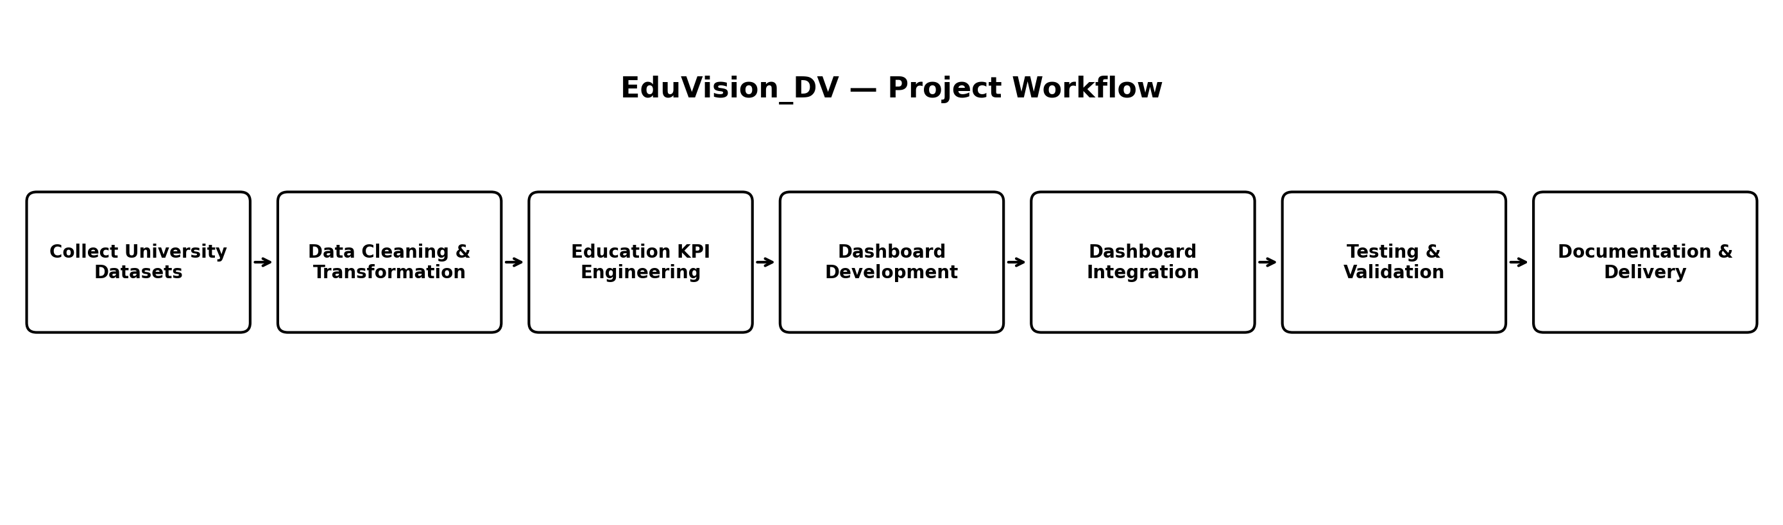

3. Dataset Sources
The project uses two university-ranking datasets: QS World University Rankings 2026 and Times Higher Education (THE) World University Rankings 2026.
Dataset | Role | Important indicators
QS World University Rankings 2026 | Ranking and performance analysis | QS Rank, Overall Score, Academic Reputation, Employer Reputation, Faculty Student Ratio, Citations per Faculty, International Faculty, International Student, International Research Network, Employment Outcomes, Sustainability
THE World University Rankings 2026 | Ranking and performance analysis | THE Rank, Overall Score, Student Population, Students to Staff Ratio, International Students, Female to Male Ratio, Teaching, Research Environment, Research Quality, Industry Impact, International Outlook
The current working merged dataset used in the analysis contains 657 rows and 27 columns.

4. Data Cleaning & Transformation
The workflow included duplicate handling, university-name standardization, country standardization, ranking transformations, missing-value treatment, year filtering, and QS/THE integration.

University Name Standardization
Parenthetical text was removed from university names and surrounding spaces were stripped. This helps improve matching when QS and THE use slightly different name formats.

QS Rank Transformation
QS contains exact ranks and rank ranges. For numerical KPI calculations, rank ranges were converted to their midpoint while the original QS Rank column was retained.
Original QS Rank | Numeric value used
701-710 | 705.5
751-800 | 775.5
1201-1400 | 1300.5

Missing Values
QS Overall Score values represented by '-' were converted to missing for calculation and filled using the median of the QS Overall Score column in the working merged dataframe.

THE Year Filtering
The THE data was filtered to 2026 records for the current analysis. The resulting THE cleaned dataset contained 2,191 records before QS/THE matching.

5. KPI Definitions
The project statement requires six higher-education KPIs. The mathematical definitions below document the derived KPI approach used in the project.

Global Ranking Score
Purpose: Combines QS and THE ranking positions.
Input columns: QS Rank Numeric; THE Rank
Method: Normalize both rank positions to a 0–100 direction where higher is better, then average them.
Interpretation: Higher = stronger combined ranking position.

Research Impact Score
Purpose: Summarizes research-related performance.
Input columns: Citations per Faculty SCORE; International Research Network SCORE; THE Research Quality; THE Research Environment
Method: Average of the four research-related scores.
Interpretation: Higher = stronger research performance.

Faculty-to-Student Ratio
Purpose: Measures student load relative to faculty/staff availability.
Input columns: Student Population and staff/faculty-related indicators
Method: Derived from the available student/staff measures in the final dataset.
Interpretation: Used to compare student-to-staff conditions.

International Student Percentage
Purpose: Measures international student representation.
Input columns: International Students; Student Population
Method: International Students ÷ Student Population × 100.
Interpretation: Higher = greater international representation.

Academic Reputation Score
Purpose: Represents the QS academic reputation indicator.
Input columns: Academic Reputation SCORE
Method: Uses the QS academic reputation score.
Interpretation: Higher = stronger academic reputation.

Research Productivity Index
Purpose: Represents overall research productivity.
Input columns: Selected research-performance indicators
Method: Derived by combining selected research indicators into one analytical measure.
Interpretation: Higher = stronger research productivity.
Note: The project statement names the six KPIs but does not prescribe mathematical formulas for each KPI; the methods above document the project's derived KPI approach.

6. Dashboard Guide

University Overview
- Top Universities – Global Ranking Score
- Academic Reputation
- Institutional Comparison – QS vs THE Overall Score
- University Performance Distribution
- Teaching Score by Region
- University Distribution by Country
- Ranking Score vs Academic Reputation

Research Analytics
- Research Impact
- Research Quality
- Research Environment
- Research Productivity
- Research Impact vs Productivity
- Research Quality Distribution

Student Analytics
- International Students
- Student Population
- Female-Male Ratio
- Faculty-Student Ratio
- Employment Outcomes
- QS Overall Score

Country Comparison
- Average Ranking
- Research Impact
- Academic Reputation
- Student Population
- Universities by Country
- Research Impact vs Academic Reputation

Interactive Features
- Global filters
- Navigation controls
- Parameter actions
- Dashboard linking
- Interactive comparisons and drill-downs

7. Education Analytics Methodology
- Collect QS and THE ranking datasets.
- Inspect data types, missing values, and duplicates.
- Standardize university names and country names.
- Filter the relevant ranking year.
- Convert QS rank ranges to numeric representations for calculations.
- Treat missing or '-' values appropriately.
- Match QS and THE records using standardized Name and Country fields.
- Create the merged analytical dataset.
- Engineer the six KPIs.
- Prepare the Tableau-ready dataset.
- Build and integrate four Tableau dashboards.
- Test KPI calculations, ranking calculations, dashboard interactions, and educational metrics.

8. Technology Stack
Area | Technology / Tool
Data Collection | Python, QS Rankings, World University Rankings
Data Processing | Pandas, NumPy
Data Cleaning | Python
Visualization | Tableau Desktop / Tableau Public
Dashboard Integration | Tableau Filters, Parameters, Actions
Documentation | Markdown, GitHub

9. Project Structure
EduVision_DV/
├── scripts/ → data_collection.py, generate_education_kpis.py
├── data/ → raw/ and processed/ datasets
├── dashboard/ → EduVision_DV.twbx
└── docs/ → README.md, KPI_Documentation.md, Dashboard_Guide.md, Methodology.md

10. Testing & Validation
Validation area | Check
KPI calculations | Verify formulas and output values.
Ranking calculations | Verify QS/THE transformations and derived ranking score.
Dashboard interactions | Test filters, navigation, parameters, and linking.
Educational metrics | Check research, student, reputation, and country indicators.

